**CUSTOMER CHURN**

**ANALYSIS AND BUSINESS INTELLIGENCE REPORT**

**BY**

**JAYITA MONDAL | ABHRADEEP SEN | ARKAPRAVA GHOSH | KUNAL NANDI**

**PROJECT OVERVIEW & GOALS**

**Business context:** Customer churn is costly, retaining customers is more profitable than acquiring new ones.

**Goal:** Identify churn drivers, understand customer behavior, and propose data-driven retention strategies.

**Approach:** Multi-tool pipeline from raw data → visualization → insights.

**Tech & Tools Used**

**Excel →** Data Cleaning, preprocessing.

**MySQL** → Business queries & structured insights.

**Python (Jupyter Notebook)** → Deep Exploratory Data Analysis (EDA), visualizations.

**Power BI** → Interactive dashboards for stakeholders.

**COMPREHENSIVE PROJECT SUMMARY**

This project includes a Jupyter notebook, a SQL script, and a Power BI dashboard, detail a comprehensive Customer Churn Analysis.The analysis focuses on identifying key factors contributing to customer attrition and providing actionable recommendations to improve customer retention. The project effectively combines data analysis, SQL-based insights, and interactive data visualization to present a cohesive and actionable report.

**CUSTOMER CHURN ANALYSIS : EXCEL**

* For this project we used total 3 datasets (Churn Data, Customer Data and Internet Data).
* We used Excel for data preprocessing process.
* Removed duplicates, missing values, formatting issues.
* Standardized categorical variables (e.g., Yes/No, contract types).
* Ensured numeric fields (charges, tenure) were clean for modeling.

**CUSTOMER CHURN ANALYSIS :POWER BI**

**Page 1 : NUMERICAL ANALYSIS**

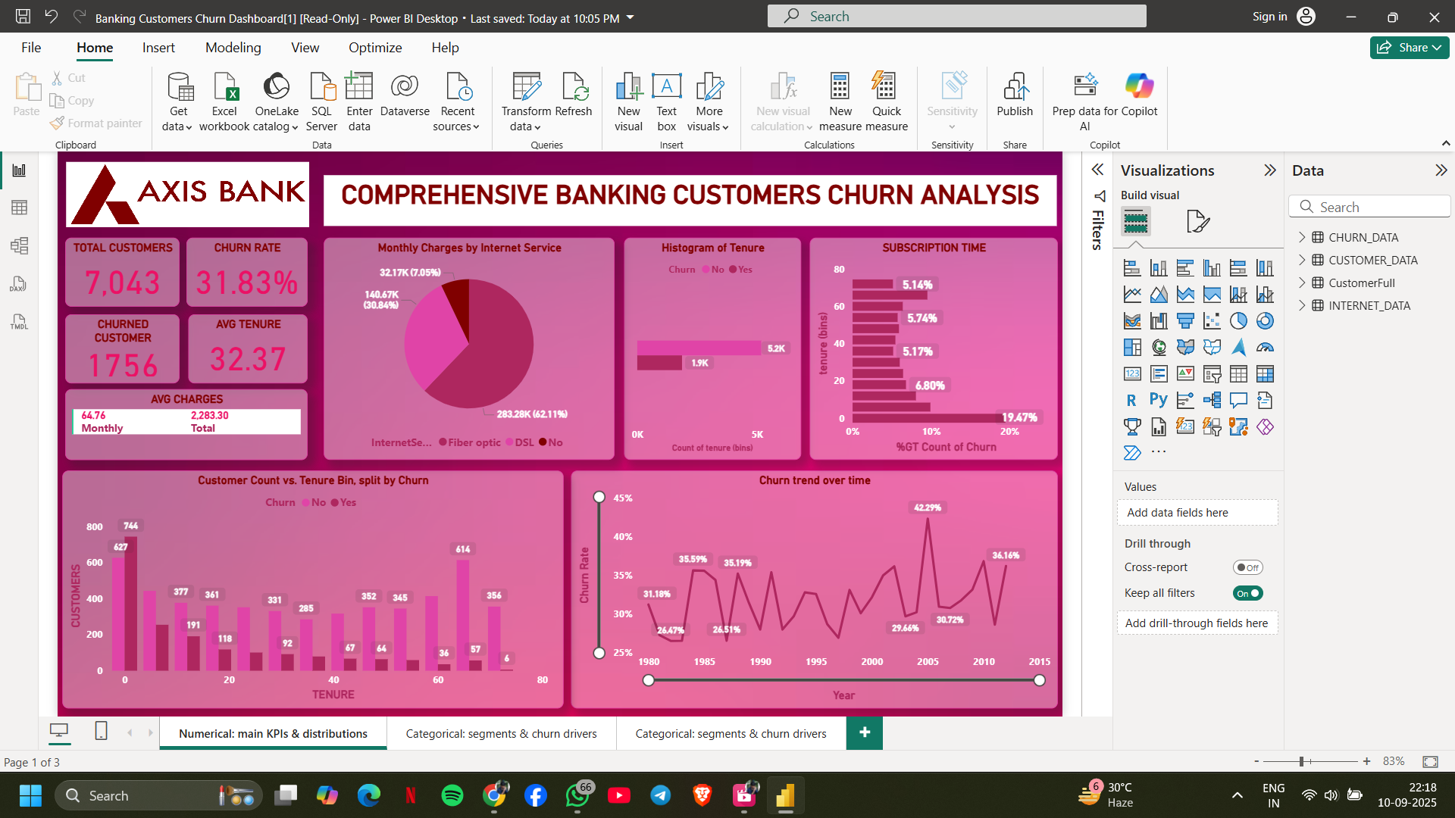

**INSIGHTS:**

* Total Customers: 7,043
* Churn Rate: 31.83% (quite high — almost 1 in 3 customers leave).
* Churned Customers: 1,756
* Average Tenure: 32.37 months (~2.7 years) → suggests customers don’t stay very long.
* Average Monthly Charges: 647.6

**Insight**: High churn rate indicates an urgent need for retention strategies. Customers are not staying long, and this impacts profitability.

* Churn by Internet Service (Pie Chart)
* Majority (62.11%) are DSL users.
* Around 30.84% are Fiber optic users.
* Smaller group: 7.05% with no internet service.

**Insight:** Fiber optic customers may have higher churn compared to DSL (needs validation by churn %). The type of service significantly affects retention.

* Tenure Distribution (Histogram)
* Most churned customers have low tenure (0–20 months).
* Customers staying beyond 60 months show much lower churn.

**Insight:** Churn risk is highest in the early customer lifecycle. First 1–2 years are critical for building loyalty.

* Subscription Time (Bar Graph)
* Highest churn segment: 19.47% at around 70+ months, but majority of churn still happens early.

**Insight:** Although long-tenure customers eventually churn, the bulk of churn occurs earlier — pointing to onboarding and engagement gaps.

* Churn Trend Over Time
* Churn fluctuates over the years.
* Peaks: 42.29% (around early 2000s).
* Dips: 26.51% (mid-1980s).
* Recent churn ~36.14%.

**Insight:** Churn trend is inconsistent — possible external factors (competition, policies, interest rates, digital transformation) impacting loyalty.

**PAGE 2 : CATEGORICAL ANALYSIS**

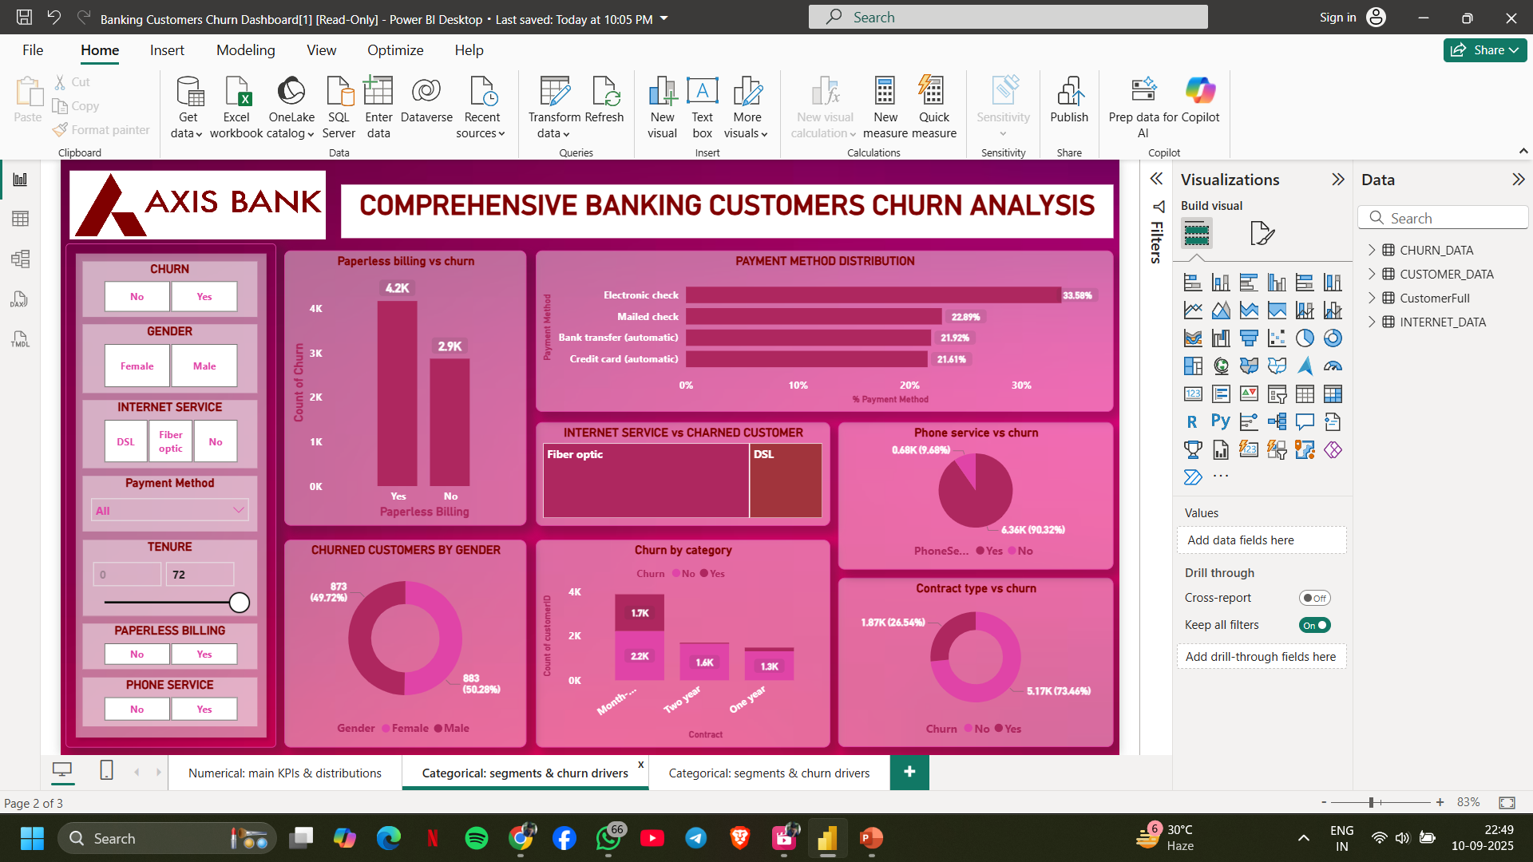

**INSIGHT :**

**Paperless Billing vs Churn**

* Customers with **paperless billing (4.2K)** churn more than those without (2.9K).  
   Possible cause: digital-only customers may feel less engaged with physical touchpoints.

**Payment Method Distribution**

* **Electronic check (33.56%)** is the most used payment method.
* Mailed check (22.89%), bank transfer (21.92%), and credit card auto-pay (21.61%) follow.  
   Churn tends to be higher among electronic check users — this payment type is a churn driver.

**Internet Service vs Churned Customers**

* Fiber optic users churn **more** than DSL users.  
   Service quality and price sensitivity likely issues for fiber optic customers.

**Phone Service vs Churn**

* Majority (90.32%) have phone service → churn is not strongly linked to phone service presence.

**Churned Customers by Gender**

* Male: 883 (50.28%)
* Female: 873 (49.72%)  
   Gender has little impact on churn.

**Churn by Contract Type**

* **Month-to-month contracts** have the **highest churn (1.87K = 25.54%)**.
* Yearly or 2-year contracts show much lower churn.  
  Contract length strongly influences loyalty. Long-term contracts retain customers better.

**PAGE 3:**

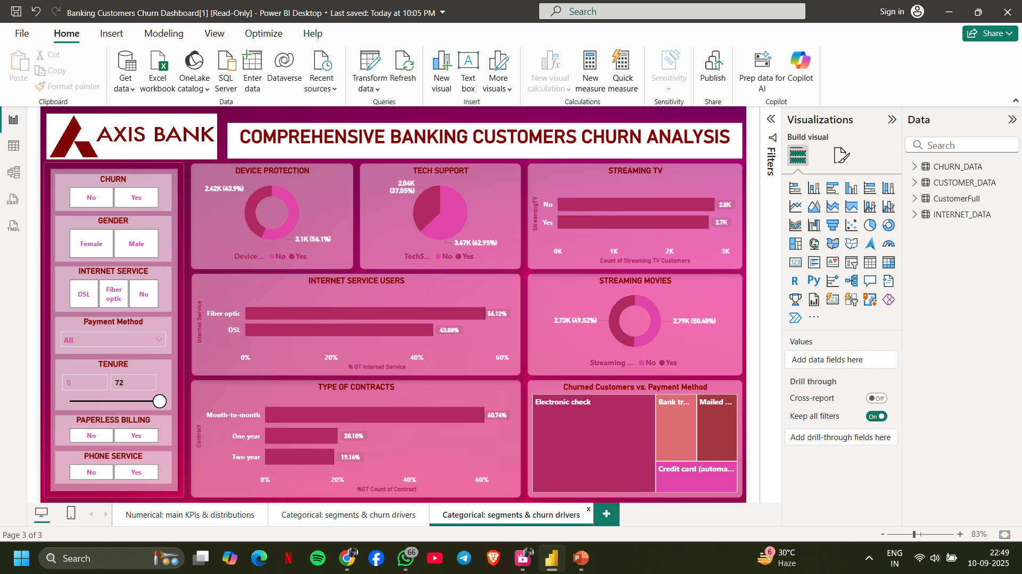

**INSIGHTS :**

1. **Device Protection**
   * Without device protection: 2.42K churned (43.9%).
   * With device protection: 3.11K churned (56.1%).  
      Unexpected — even with added protection, churn remains high → perhaps service isn’t valued or seen as costly.
2. **Tech Support**
   * No tech support: 3.47K (62.95%) churn.
   * With tech support: 2.04K (37.05%).  
     Lack of technical support is a major churn driver.
3. **Streaming Services**
   * Streaming TV users: churn nearly equal (~2.8K vs 2.7K).
   * Streaming Movies: churn evenly split (~50%).  
     Entertainment add-ons do not prevent churn; they don’t add strong retention value.
4. **Internet Service Users**
   * Fiber optic: 54.12% of total users.
   * DSL: 43.88%.  
      Fiber optic dominance, but higher churn sensitivity here.
5. **Type of Contracts**
   * **Month-to-month contracts (60.74%)** dominate.
   * Only ~20% yearly, ~19% 2-year.  
      The reliance on short contracts fuels churn. Incentivizing long-term plans could help.
6. **Churn by Payment Method**
   * Electronic check customers churn the most.

Automatic payment methods (bank transfer, credit card) correlate with lower churn.Frictionless payment methods encourage customer stickiness.

**CUSTOMER CHURN ANALYSIS : SQL**

**(1) Calculate the overall churn rate from the main customer data :**

select count(*) as total_customers ,

sum(case when Churn= 'Yes' then 1 else 0 end ) as churned_customers ,

Round(sum(case when Churn= 'Yes' then 1 else 0 end ) * 100 / count(*) , 2) as churn_rate

from churn_data ;

**ANSWER-**

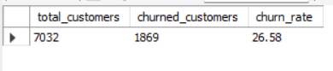

**(2) Find the average monthly charges for churned vs non-churned customers:**

select AVG(case when Churn = "Yes"then MonthlyCharges END) as Average_churned_customer,

Avg(case when Churn = "No" then MonthlyCharges end) as average_nonchurned_customers

from churn_data ;

**ANSWER-**

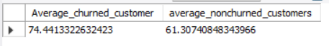

**(3) List the top 5 payment methods with the highest churn rates.**

select PaymentMethod , count(*) as total_customers ,

sum(case when Churn= 'Yes' then 1 else 0 end ) as churned_customers ,

Round(sum(case when Churn= 'Yes' then 1 else 0 end ) * 100 / count(*) , 2) as churn_rate

from churn_data

group by PaymentMethod

order by churn_rate desc limit 5 ;

**ANSWER-**

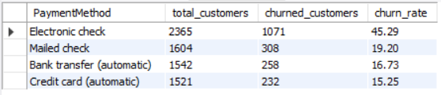

**(4) Display the number of customers on each contract type who have churned :**

select Contract , count(Churn) from churn_data where Churn = 'Yes' group by Contract ;

**ANSWER -**

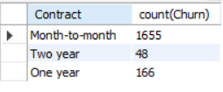

**5)Count how many customers have tenure less than 12 months and have churned:**

select count(*) as no_of_customer_tenure_lessthan12 from churn_data where tenure <12 and Churn='Yes' ;

**ANSWER-**



**(6) Identify how many customers have paperless billing and are paying through electronic check :**

select count(*) as no_of_customers from churn_data where PaperlessBilling = 'Yes' and PaymentMethod = 'Electronic check' ;

**ANSWER-**



**(7) Calculate the total revenue generated from non-churned customers only.**

select sum(TotalCharges) as total_revenue_non_churned from churn_data where Churn = 'No' ;

**ANSWER-**



**(8) List customers who have never used phone service or internet service.**

select ch.customerID , ch.PhoneService , i.InternetService

from churn_data as ch

join internet_data as i

on ch.customerID = i.customerID

where ch.PhoneService = 'No'

and i.InternetService = 'No' ;

**ANSWER-**

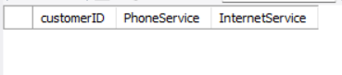

**(9) Find the number of customers with ‘Month-to-month’ contracts and no online security**.

select count(*) as no_of_customers from churn_data as ch

join internet_data as i

on ch.customerID = i.customerID

where ch.Contract = 'Month-to-month'

and i.OnlineSecurity = 'No' ;

**ANSWER-**



**(10) Show the churn rate grouped by senior citizen status.**

select SUM(CASE WHEN Churn = 'Yes' THEN 1 END) * 100.0 / COUNT(*) AS ChurnRate, t2.SeniorCitizen

from churn_data as t1

join customer_data as t2 on t1.customerID = t2.customerID

group by t2.SeniorCitizen;

**ANSWER-**



**(11) Determine the average customer age for churned vs non-churned customers.**

select t1.Churn, Avg(2025 - (t2.year)) as AverageAge

from churn_data as t1

join customer_data as t2

on t1.customerID = t2.customerID

group by t1.Churn;

**ANSWER**

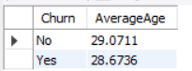

**(12) List customers with Fiber optic internet who are using all entertainment services (StreamingTV and StreamingMovies).**

select customerId , InternetService,StreamingMovies,StreamingTV

from internet_data

where InternetService = 'Fiber optic'

and StreamingTV = 'Yes'

and StreamingMovies = 'Yes' ;

**ANSWER-**

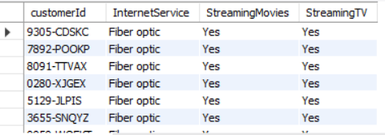

**(13) Identify the top 5 customers who have paid the highest total charges but still churned.**

select customerID , TotalCharges , Churn from churn_data where Churn = 'Yes' order by TotalCharges desc limit 5 ;

**ANSWER-**

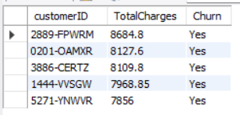

**(14) Find customers who are not senior citizens now, but will turn 65 within the next 2 years.**

select customerID from customer_data where SeniorCitizen = 'No' and (2025 - year) >= 63 ;

**ANSWER-**

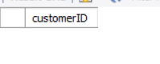

**(15) Get a list of customers who are using all possible services (phone, internet, backup, security, streaming, tech support).**

select ch.customerID, ch.PhoneService, i.InternetService, i.OnlineSecurity, i.OnlineBackup, i.TechSupport, i.StreamingTV, i.StreamingMovies

from internet_data as i

join churn_data as ch

on i.customerID = ch.customerID

where i.InternetService = 'Yes'

and i.OnlineSecurity= 'Yes'

and i.OnlineBackup = 'Yes'

and i.TechSupport = 'Yes'

and i.StreamingTV = 'Yes'

and i.StreamingMovies = 'Yes'

and ch.PhoneService = 'Yes' ;

**ANSWER –**



**(16) Calculate the churn rate by age group: <30, 30–50, 51–64, 65+.**

select case when (2025 - t1.year) < 30 then '<30'

WHEN (2025 - T1.year) between 30 AND 50 then '30-50'

when (2025 - T1.year) between 51 and 64 then '51-64'

else '65+'

end as AgeGroup,

count(case when T2.Churn = 'Yes' then 1 end) * 100 / count(*) AS ChurnRate

from customer_data as t1

JOIN churn_data as t2

on t1.customerID = t2.customerID

group by AgeGroup

order by AgeGroup;

**ANSWER-**

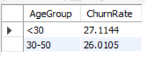

**(17) Using a subquery, find customers whose total charges are above the average of all churned customers.**

select customerID, TotalCharges from churn_data

where TotalCharges > (select avg(TotalCharges) from churn_data where churn = 'Yes');

**ANSWER-**

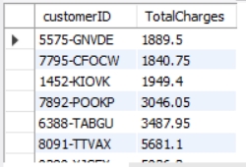

**(18) Determine the correlation between long tenure (>= 24 months) and churn. Do loyal customers churn less?**

select case when tenure >= 24 then 'Long_Tenure'

else 'Short_Tenure'

end as LoyaltyStatus,

sum(case when Churn = 'Yes' then 1 else 0 end) * 100 / COUNT(*) as ChurnRate from churn_data

group by LoyaltyStatus;

**ANSWER-**

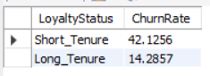

**(19) Create a report showing monthly churn trend — how many customers churned each month.**

select tenure as ChurnMonth,

count(*) as ChurnedCustomers

from churn_data

where Churn = 'Yes'

group by ChurnMonth

order by ChurnMonth;

**ANSWER-**

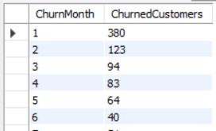

**(20)Rank customers by revenue (total charges) within each contract type using window functions.**

select customerID, Contract, TotalCharges,

rank() over (partition by Contract order by TotalCharges desc) AS revenue_rank

FROM CHURN_DATA

ORDER BY Contract ,

revenue_rank ;

**ANSWER-**

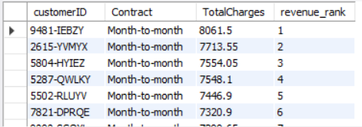

**(21)Using a CTE, list customers who have either no protection services (OnlineSecurity, Backup, DeviceProtection) and have churned.**

WITH Combinedtable AS (

select

c.customerID,c.gender,c.Partner,c.Dependents,

i.OnlineSecurity,i.OnlineBackup,i.DeviceProtection,

ch.Churn

from CUSTOMER_DATA c

join INTERNET_DATA i

on c.customerID = i.customerID

join CHURN_DATA ch

on c.customerID = ch.customerID

)

select

customerID,gender,OnlineSecurity,OnlineBackup,DeviceProtection,Churn

from Combinedtable

where

Churn = 'Yes'

AND OnlineSecurity = 'No'

AND OnlineBackup = 'No'

AND DeviceProtection = 'No';

**ANSWER-**

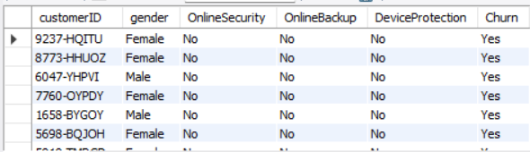

**(22)I want a to check how many days, month and year is left for each and every employee to reach the Senior Citizen**

select customerID, DOB,

date_add(DOB, INTERVAL 65 YEAR) AS senior_citizen_date,

TIMESTAMPDIFF(YEAR, curdate(), date_add(DOB, INTERVAL 65 YEAR)) AS years_left,

mod(TIMESTAMPDIFF(MONTH, curdate(),date_add(DOB, INTERVAL 65 YEAR)),12) AS months_left,

mod(TIMESTAMPDIFF(DAY, curdate(), date_add(DOB, INTERVAL 65 YEAR)), 30) AS days_left

FROM CUSTOMER_DATA;

**ANSWER-**

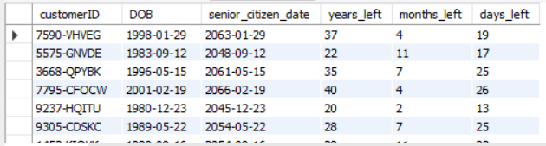

**Customer Churn Analysis : EDA**

This report summarizes the Exploratory Data Analysis (EDA) performed on the customer churn dataset. The notebook was executed in Python using popular data science libraries.

# Tools & Libraries Used

- Python  
- Pandas  
- NumPy  
- Matplotlib  
- Seaborn  
- Scikit-learn  
- Jupyter Notebook

# Goal of the EDA

The primary goal of this EDA is to understand the factors contributing to customer churn, explore patterns in customer behavior, and visualize insights that may guide business decisions.

# Dataset

* Dataset file(s) referenced in notebook:

- `INTERNET_DATA .csv`

- `CHURN_DATA.csv`

- `CUSTOMER_DATA.csv`**Table of Contents:**

* Import Libraries
* Load the Datasets
* Basic Data Cleaning
* Exploratory Data Analysis (EDA)

--- Univariate Analysis ---

1. Count of Churn
2. Distribution of MonthlyCharges
3. Distribution of TotalCharges
4. Distribution of Tenure
5. Count of Contract Types
6. Count of Payment Methods

--- Bivariate Analysis ---

1. Churn vs Gender
2. Churn vs Internet Service
3. Churn vs Dependents
4. Churn vs Partner
5. Churn vs OnlineSecurity
6. Churn vs TechSupport

--- Multivariate Analysis ---

1. Monthly Charges vs Tenure with Churn
2. Tenure vs MonthlyCharges by Churn
3. Monthly Charges across Contract Types by Churn

--- Customer Churn Analysis ---

1. Overall Churn Rate
2. Churn Rate by Contract Type
3. Average Monthly Charges (Churn vs Non-Churn)
4. Average Tenure (Churn vs Non-Churn)
5. Churn by Contract Type
6. Churn by Contract
7. Churn by Payment Method
8. Overall Churn % Pie Chart
9. Churn Rate by Gender
10. Churn by Internet Service
11. Churn by Payment Method
12. Average Monthly Charges for Churn vs Non-Churn
13. Average Tenure for Churn vs Non-Churn
14. Customer Churn Count by Year
15. Churn rate (%) by Year

* **Import Libraries**

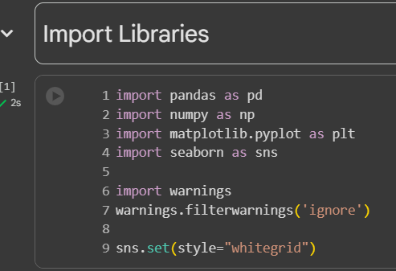

* **Load the Datasets**

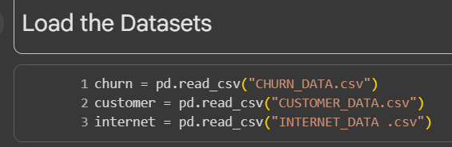

* **Basic Data Cleaning**

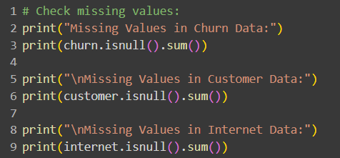

* **Exploratory Data Analysis (EDA)**

**Univariate Analysis ---**

* 1. **Count of Churn**

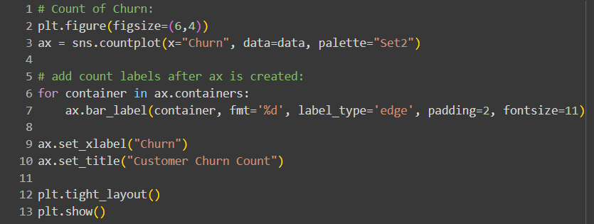

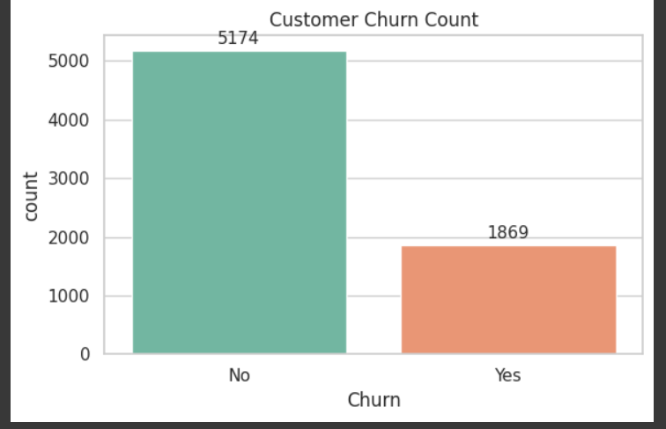

Approximate counts show around 5.1k non-churn vs 1.9k churn, so retention is roughly 3 times higher than churn.

* 1. **Distribution of MonthlyCharges**

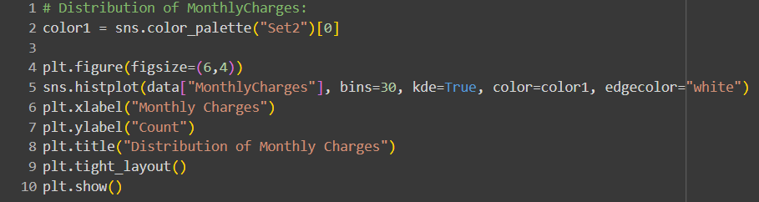

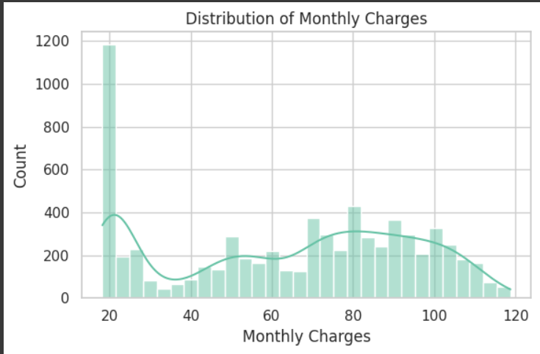

Customer tenure is concentrated at the very beginning and end of the range, with many new customers and a noticeable spike near 70–72 months.

* 1. **Distribution of ContractTypes**

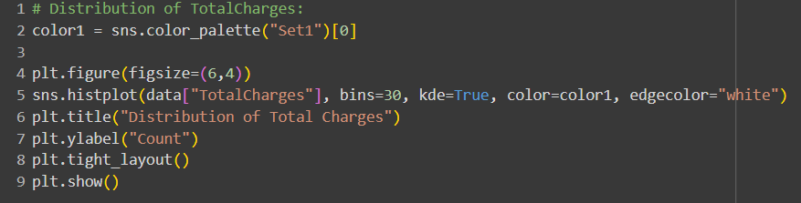

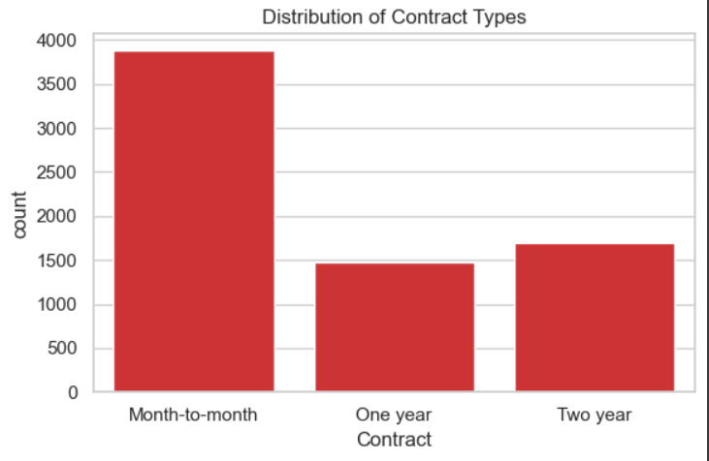

Most customers are on month-to-month contracts, while one-year and two-year contracts have much smaller and roughly similar counts.

* 1. **Distribution of Tenure**

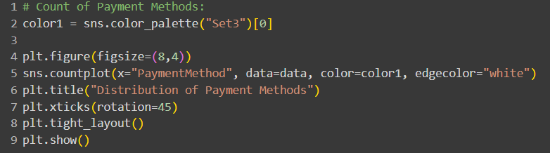

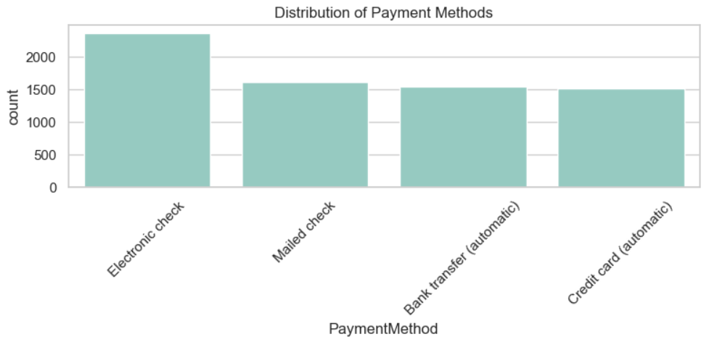

Electronic check is the most used payment method, while the three others have similar and lower adoption.

**BIVARIATE ANALYSIS--**

**1.**

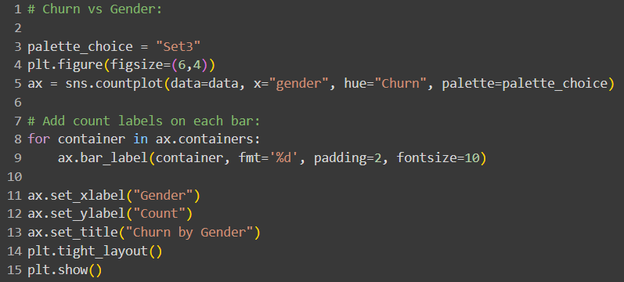

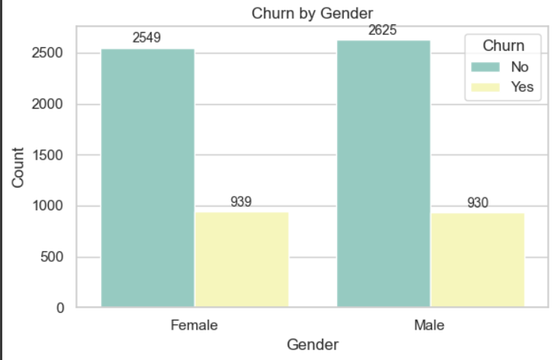

Churn rates look similar for males and females, with both groups showing many more retained customers than churned ones.

-- Female: ~2549 no-churn vs ~939 churn, indicating higher retention than churn.

-- Male: ~2625 no-churn vs ~930 churn, very close to females and also retention-dominant.

-- Gender does not appear to be a strong driver of churn differences in this dataset.

**2.**

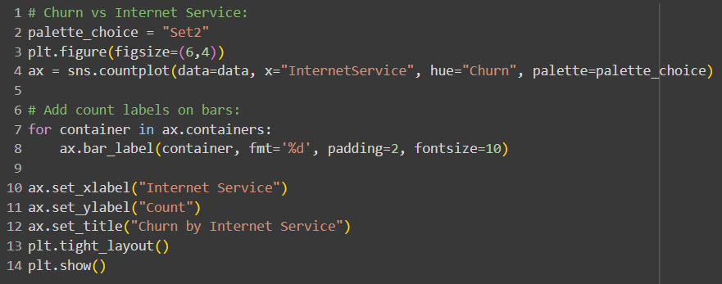

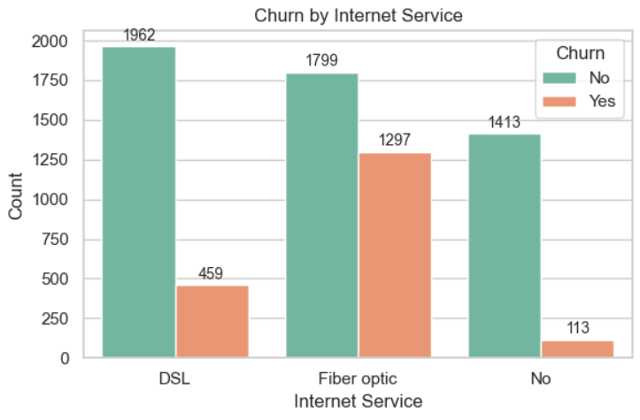

Fiber optic users show the highest churn counts, while DSL users churn less and non-internet users churn the least.

-- DSL: Many more retained (1962) than churned (459), indicating relatively stable customers.

-- Fiber optic: Retained (1799) and churned (1297) are closer, signaling higher churn risk in this segment.

-- No internet: Very low churn (113) with strong retention (1413), likely due to fewer service touchpoints or different product mix.

**3.**

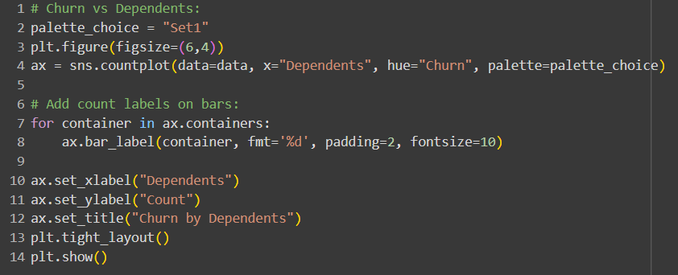

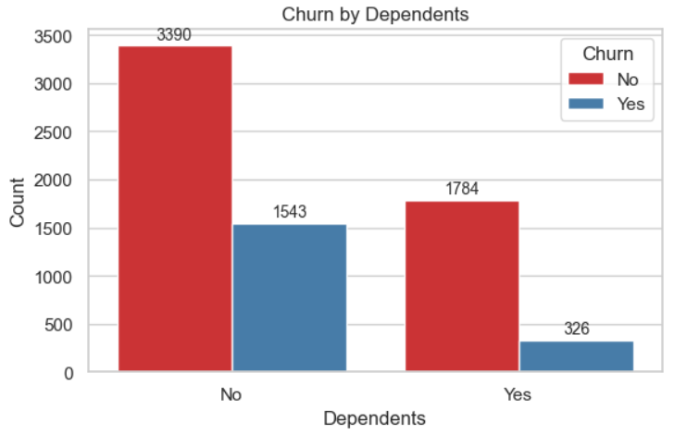

Customers without dependents churn much more than those with dependents, though retention exceeds churn in both groups.

-- No dependents: ~3390 retained vs ~1543 churned, indicating higher churn pressure in this segment.

-- With dependents: ~1784 retained vs ~326 churned, showing notably lower churn.

-- Target churn reduction efforts on customers without dependents, as they are significantly more likely to leave.

**4.**

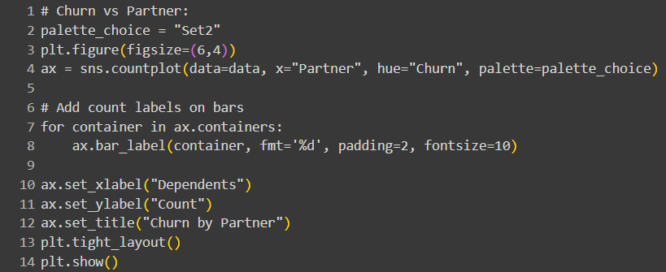

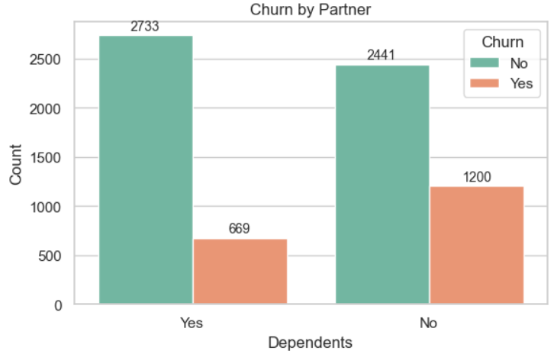

Having a partner is associated with lower churn compared to not having a partner.

-- With partner: ~2733 retained vs ~669 churned, indicating stronger stability.

-- Without partner: ~2441 retained vs ~1200 churned, showing notably higher churn levels.

-- Prioritize retention programs for customers without partners, who exhibit greater churn propensity.

**5.**

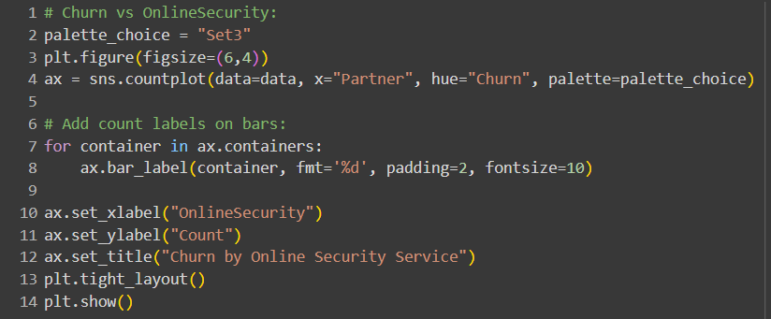

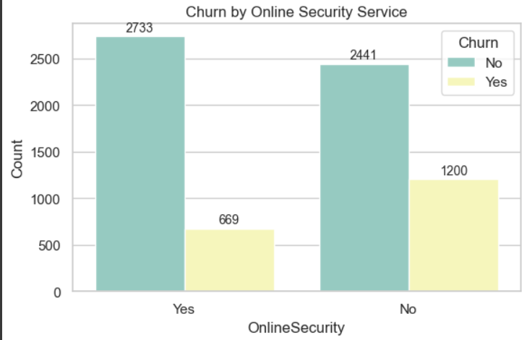

Customers with online security churn far less than those without it.

-- With security: ~2733 retained vs ~669 churned, indicating strong retention.

-- Without security: ~2441 retained vs ~1200 churned, showing markedly higher churn.

-- Promoting online security add-ons may reduce churn by shifting customers into the lower-risk group.

**6.**

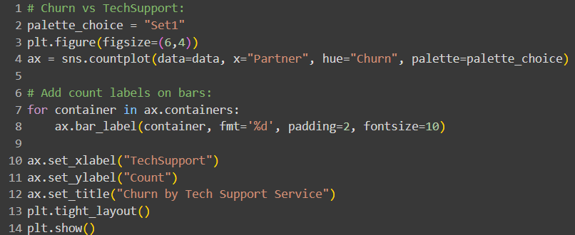

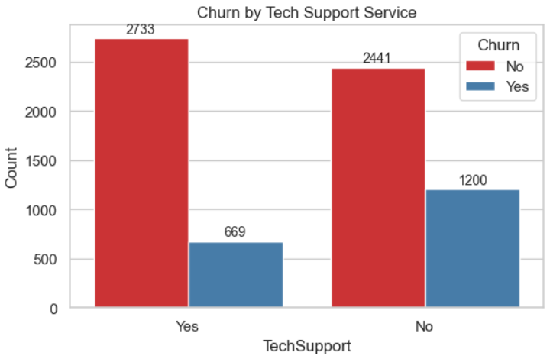

Customers with tech support churn far less than those without it.

-- With tech support: ~2733 retained vs ~669 churned, indicating strong retention.

-- Without tech support: ~2441 retained vs ~1200 churned, showing significantly higher churn.

-- Offering or bundling tech support could be an effective lever to reduce churn.

**MULTIVARIATE ANLYSIS---**

**1.**

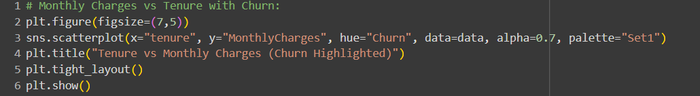

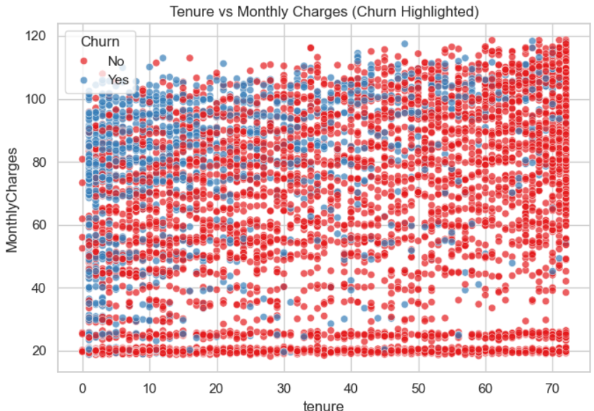

Churn is concentrated among newer customers with a range of monthly charges, while long-tenure customers show far fewer churn points across all charge levels.

-- Early tenure (0–12 months) has many blue churn points across both low and high charges, indicating onboarding and early value perception are critical.

-- As tenure increases, churn points thin out, suggesting retention improves substantially after the first year.

-- High monthly charges alone do not guarantee churn; long-tenure high-payers mostly stay, pointing to service satisfaction or bundled value.

**2.**

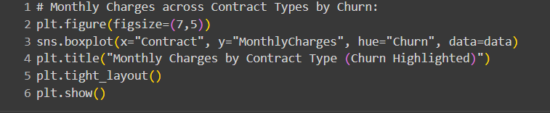

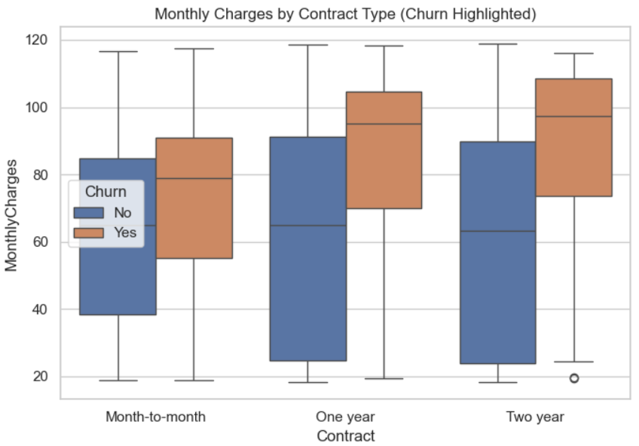

Churners pay higher monthly charges than non-churners across all contract types, and longer contracts tend to have higher charge levels overall.

-- Month-to-month: Churn medians sit above non-churn, with a wide spread indicating price sensitivity and variability.

-- One-year: Both groups shift higher than month-to-month, with churn still above non-churn, suggesting premium plan uptake among leavers.

-- Two-year: Highest charge levels overall; churners remain priced above non-churners, though non-churn IQR is broad, implying mixed plan tiers.

**CUSTOMER CHURN ANALYSIS ---**

**1.**

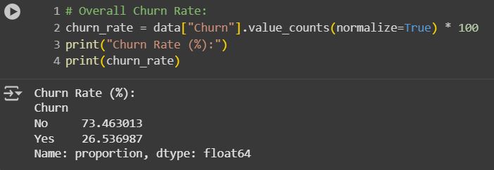

**2.**

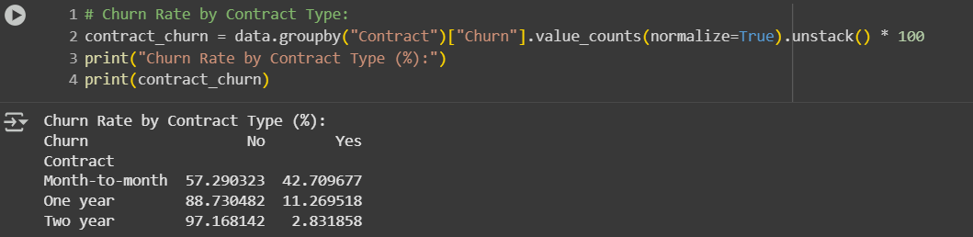

**3.**

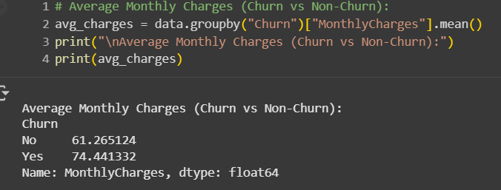

**4.**

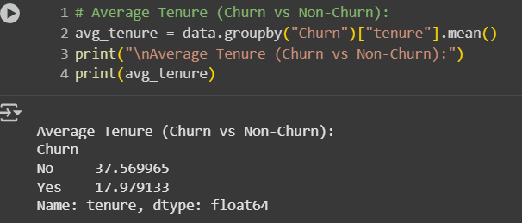

**5.**

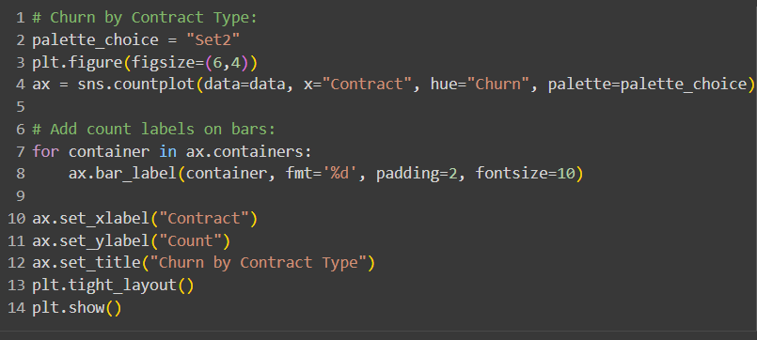

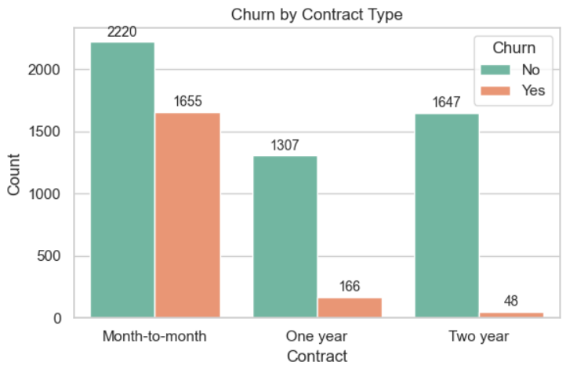

Month-to-month contracts have the highest churn, while one-year and two-year contracts exhibit very low churn.

-- Month-to-month: ~2220 retained vs ~1655 churned, indicating elevated risk among flexible plans.

-- One-year: ~1307 retained vs ~166 churned, showing strong retention with annual commitment.

-- Two-year: ~1647 retained vs ~48 churned, the lowest churn segment, reflecting the stabilizing effect of long-term contracts.

**6.**

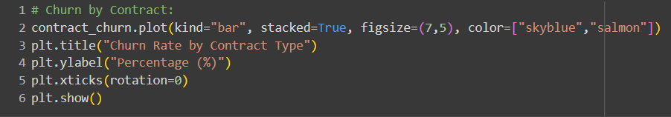

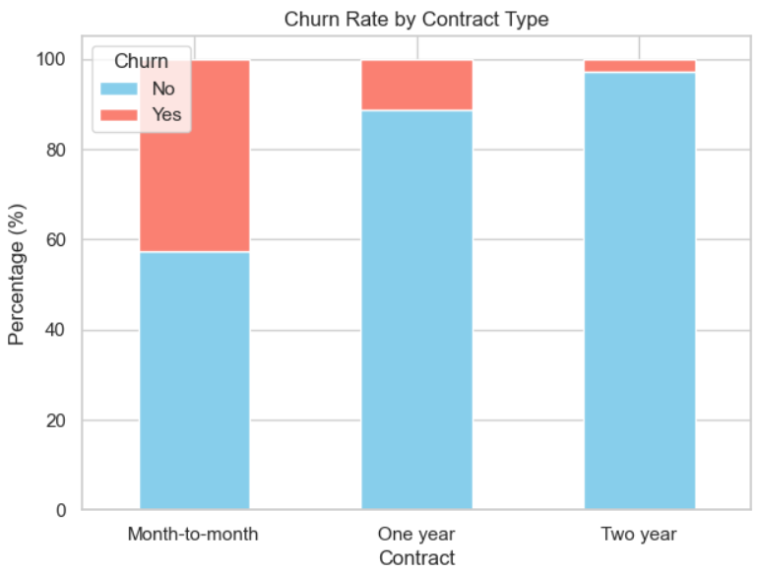

Longer contracts have much lower churn rates, with month-to-month showing the highest percentage of churners.

-- Month-to-month: A large share of the bar is churn, indicating the riskiest contract type by percentage.

-- One-year: Churn slice is small, reflecting strong retention relative to flexible plans.

-- Two-year: Churn slice is minimal, the best retention rate among all contract types.

**7.**

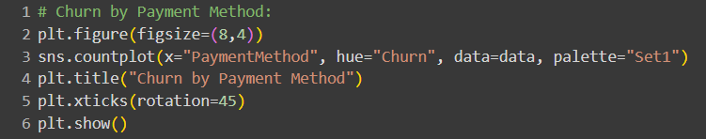

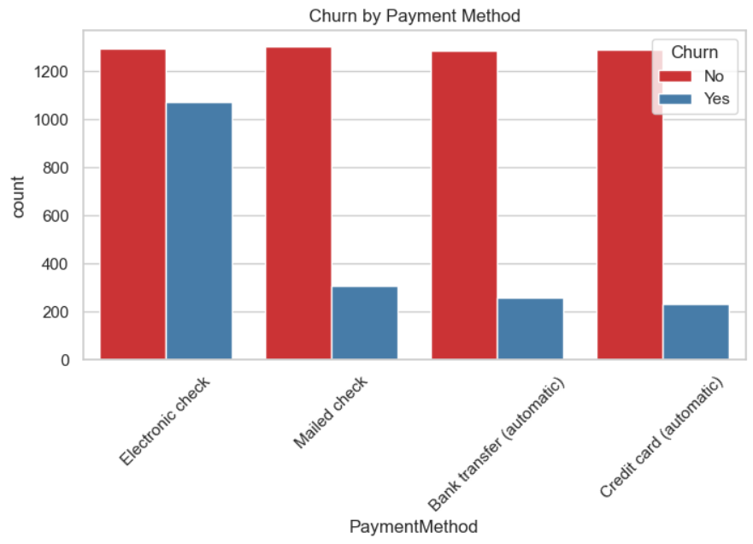

Electronic check customers churn far more than those using automatic methods or mailed checks.

-- Electronic check shows a large churn bar alongside retention, marking it the riskiest payment method.

-- Mailed check and automatic bank/credit payments have much smaller churn counts relative to retained customers.

-- Encouraging automatic payments could reduce churn by decreasing friction and missed payments.

**8.**

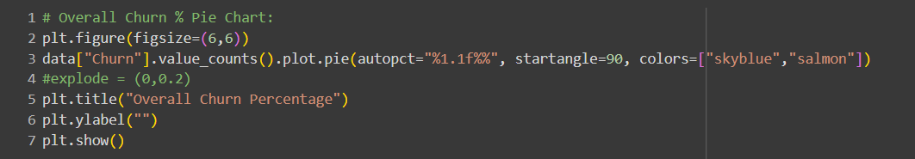

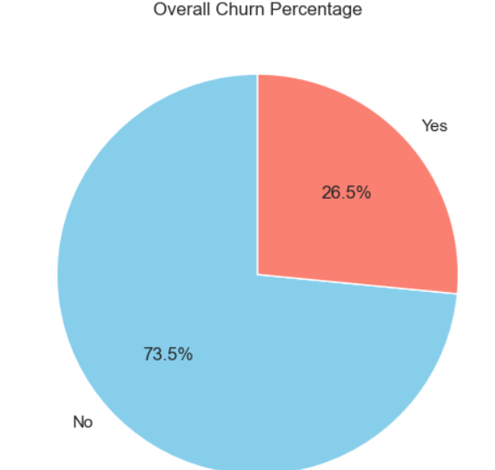

Overall churn is about 26.5%, meaning roughly three-quarters of customers are retained.

-- Retained customers (No) make up around 73.5% of the base.

-- Churned customers (Yes) account for about one-quarter, indicating meaningful but manageable attrition.

-- Monitoring this rate over time and segmenting by contract, payment, and services can pinpoint improvement levers.

**9.**

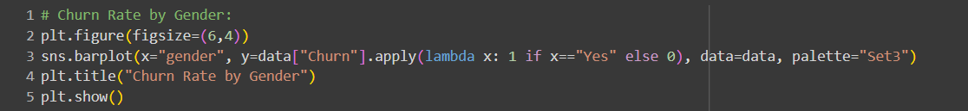

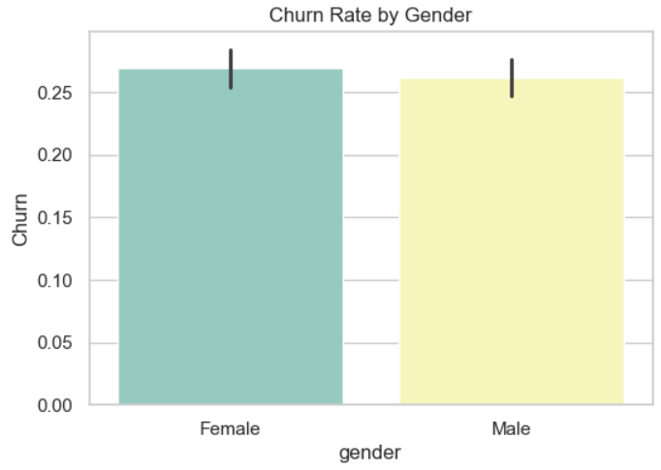

Churn rates by gender are nearly identical, with only a slight, likely insignificant difference.

-- Female churn proportion is just above 0.26, very close to male.

-- Male churn proportion is just below female’s bar, and the error bars overlap, indicating no strong gap.

-- Gender is not a meaningful predictor of churn in this dataset.

**10.**

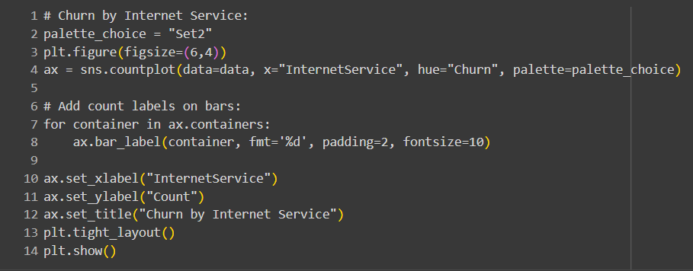

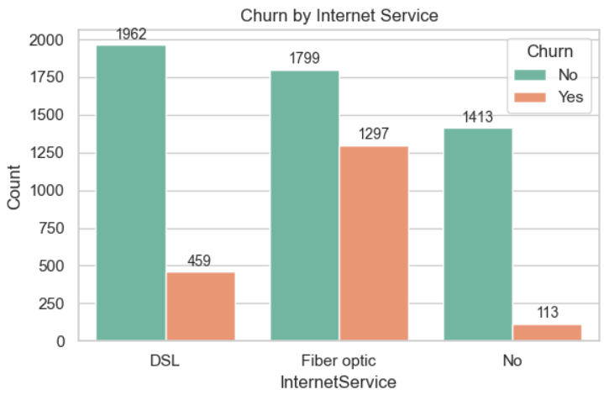

Fiber optic customers churn the most, DSL customers churn less, and customers without internet service churn the least.

-- DSL: Strong retention (1962) with comparatively low churn (459).

-- Fiber optic: Retention (1799) is close to churn (1297), indicating higher risk in this segment.

-- No internet: Highest retention (1413) with minimal churn (113), likely due to fewer service issues or a different product mix.

**11.**

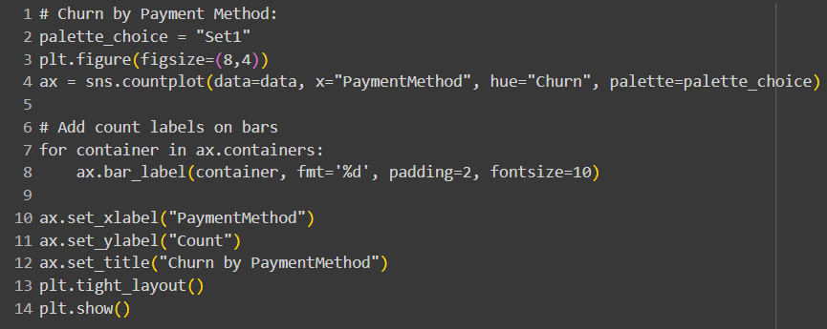

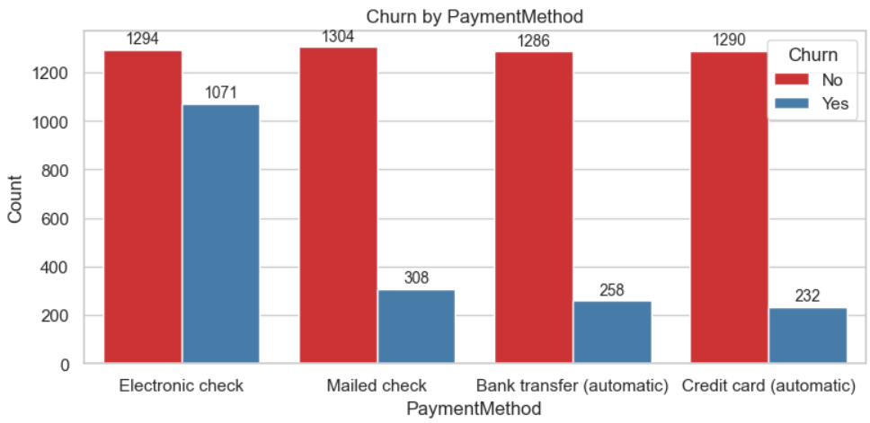

Electronic check users churn far more than users of other payment methods, while automatic bank/credit methods have the lowest churn.

-- Electronic check: High churn count (1071) close to retention (1294), marking it the riskiest segment.

-- Mailed check: Churn is much lower (308) versus retained (1304), indicating greater stability.

-- Bank transfer (auto): Low churn (258) with strong retention (1286), suggesting auto-pay improves stickiness.

-- Credit card (auto): Lowest churn (232) with high retention (1290), the safest payment group

**12.**

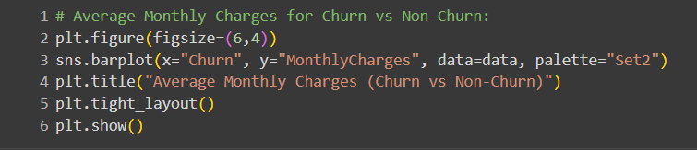

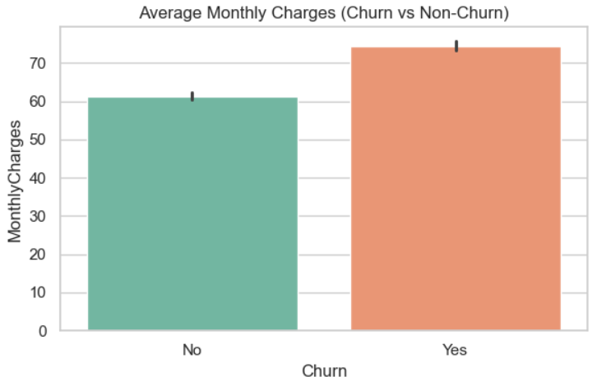

Customers who churn have higher average monthly charges than those who stay.

-- Non-churn average is around low 60s, indicating lower-cost plans correlate with retention.

-- Churn average is mid-70s, suggesting higher prices are associated with increased attrition.

-- Pricing relief or value-add bundles for high-charge segments could help reduce churn

**13.**

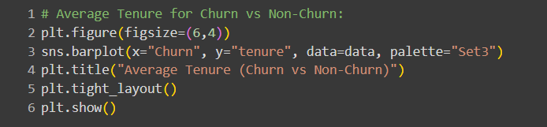

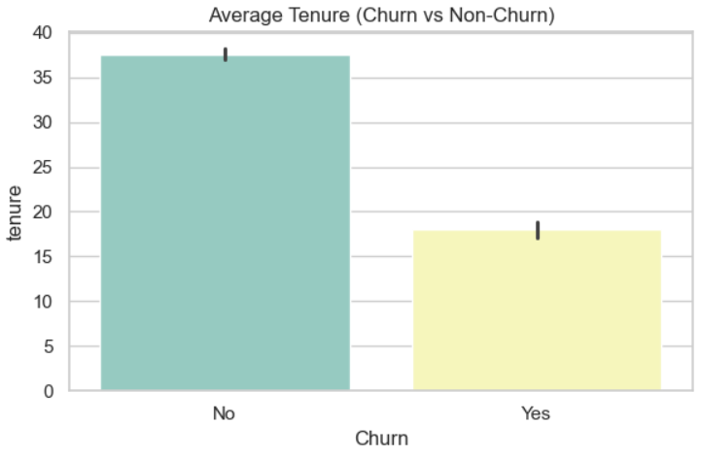

Non-churners have much higher average tenure than churners, indicating longevity strongly aligns with retention.

-- Average tenure for retained customers is around high 30s months.

-- Average tenure for churned customers is about half that, in the high teens.

-- Early lifecycle is the critical churn window; strengthening onboarding and early value can improve survival.

**14.**

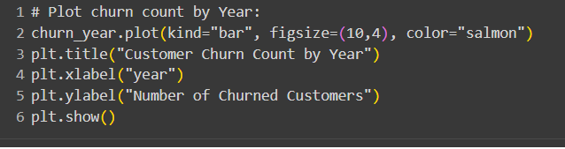

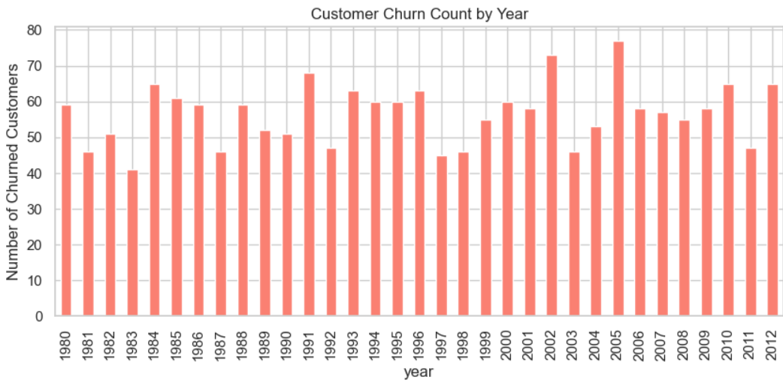

Annual churn counts fluctuate between roughly 40 and 75 per year, with notable peaks around 2002 and 2005.

-- Early years (1980s–1990s) show moderate variation, mostly in the 45–65 range.

-- Spikes occur in the early 2000s, especially 2002 and 2005, indicating periods of elevated attrition.

-- Post-2005, churn remains elevated but variable, suggesting ongoing external or pricing/service factors influencing exits.

**15.**

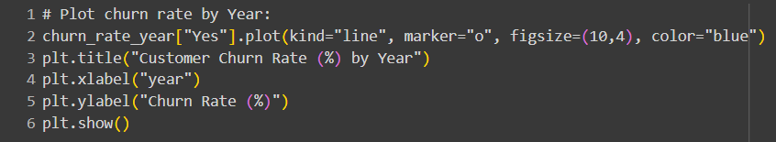

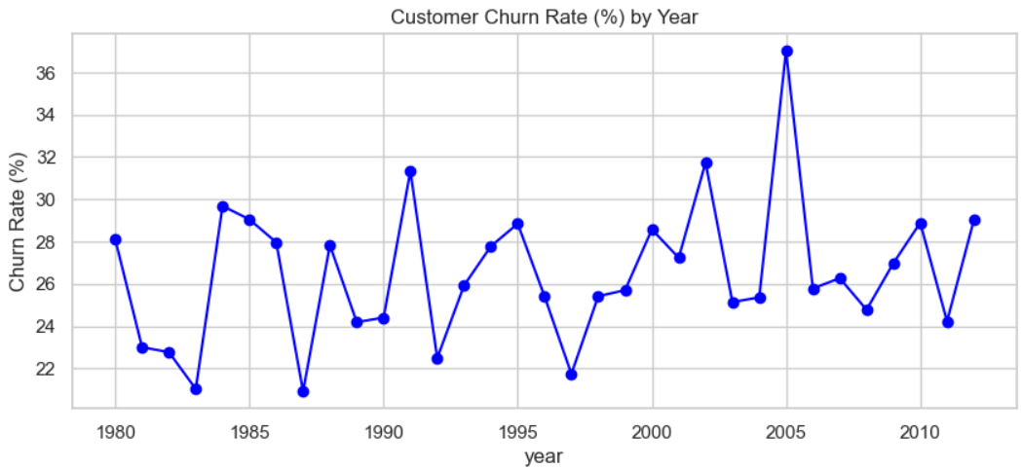

Churn rate fluctuates year to year, with a prominent spike around 2005 and smaller peaks near 1991, 1995, and 2002.

-- Early 1980s saw declines from ~28% toward low 20s, followed by a jump near 1984–1985.

-- The 1990s feature oscillations between ~21% and ~31%, with local highs around 1991 and 1995

--Early 2000s rise to a high near 32% in 2002 and the series peaks around 37% in 2005 before easing back to mid–20s to high–20s later.

----------------------------------------------------------------------------------------------------------------

**ACTIONABLE RECCOMENDATIONS**

* **Encourage customers to switch from month-to-month to yearly or two-year contracts by giving discounts or loyalty rewards.**
* **Give more support to new customers in their first 12–18 months with welcome programs, regular check-ins, and reminders to use services.**
* **Help customers with high monthly bills by offering bundles, loyalty credits, or discounts on extra services like security and tech support.**
* **Ask customers to move from electronic checks to automatic payments with bank or credit cards by giving small rewards or offers.**
* **Offer add-on services like Online Security and Tech Support because customers who use these services are less likely to leave.**
* **Pay special attention to high-risk groups like fiber internet users, people without partners or dependents, and senior citizens with special offers and care.**
* **Keep track of churn every week by contract type, payment method, tenure, and add-on services, and act quickly if churn starts to rise.**

**------------------------------------------------------------------------------------------------**

**“WINNING CUSTOMERS MATTERS, BUT KEEPING THEM BUILDS SUCCESS — DATA HELPS US PREVENT CHURN.”**

**THANK YOU**